## Global Rain Logo

**Developer**: Joseph Silva Jr

**Date**: November 17, 2019

# Summary Report Template

**Directions:** Place your pseudocode, flowchart, and explanation in the following sections. Before you submit your report, remove all bracketed [ ] text.

## Pseudocode

When you are done implementing the Pet class, refer back to the Pet BAG specification document and select either the pet check-in or check-out method. These methods are detailed in the Functionality section of the specification document.

Write pseudocode that lays out a plan for the method you chose, ensuring that you organize each step in a logical manner. Remember, you will not be creating the actual code for the method. You do **not** have to write pseudocode for both methods. Your pseudocode must not exceed one page.

|  |
| --- |
| Start  User Input dog or cat  If user inputs dog  Check if available room boarding space for dog  If available room boarding space for dog  User inputs length of stay for dog  If length of stay is 2+ days  User inputs yes or no for grooming service  If user inputs yes for grooming service  Dog scheduled for grooming service  Else  Dog not scheduled for grooming service  Else  Grooming service not available  Else  Notify user of unavailable room boarding space for dog  Else  User inputted cat  If user inputs cat  Check if available room boarding space for cat  If available room boarding space for cat  User inputs length of stay for cat  Else  Notify user of unavailable room boarding space for cat  Else  User inputted dog  After available room for user’s animal found  Animal assigned a room boarding space  User input type of customer  If user is a returning customer  Attach prior user’s personal information  If user has updated personal information  User inputs updated personal information  Else  No new information inputted  Else  User inputs new customer personal information  Stop |

## Flowchart

Based on the pseudocode you wrote, create a flowchart using a tool of your choice for the method you selected. In your flowchart, be sure to include start and end points and appropriate decision branching, and align the flowchart to the check-in/check-out process. Your flowchart must be confined to one page.

**Check In:**

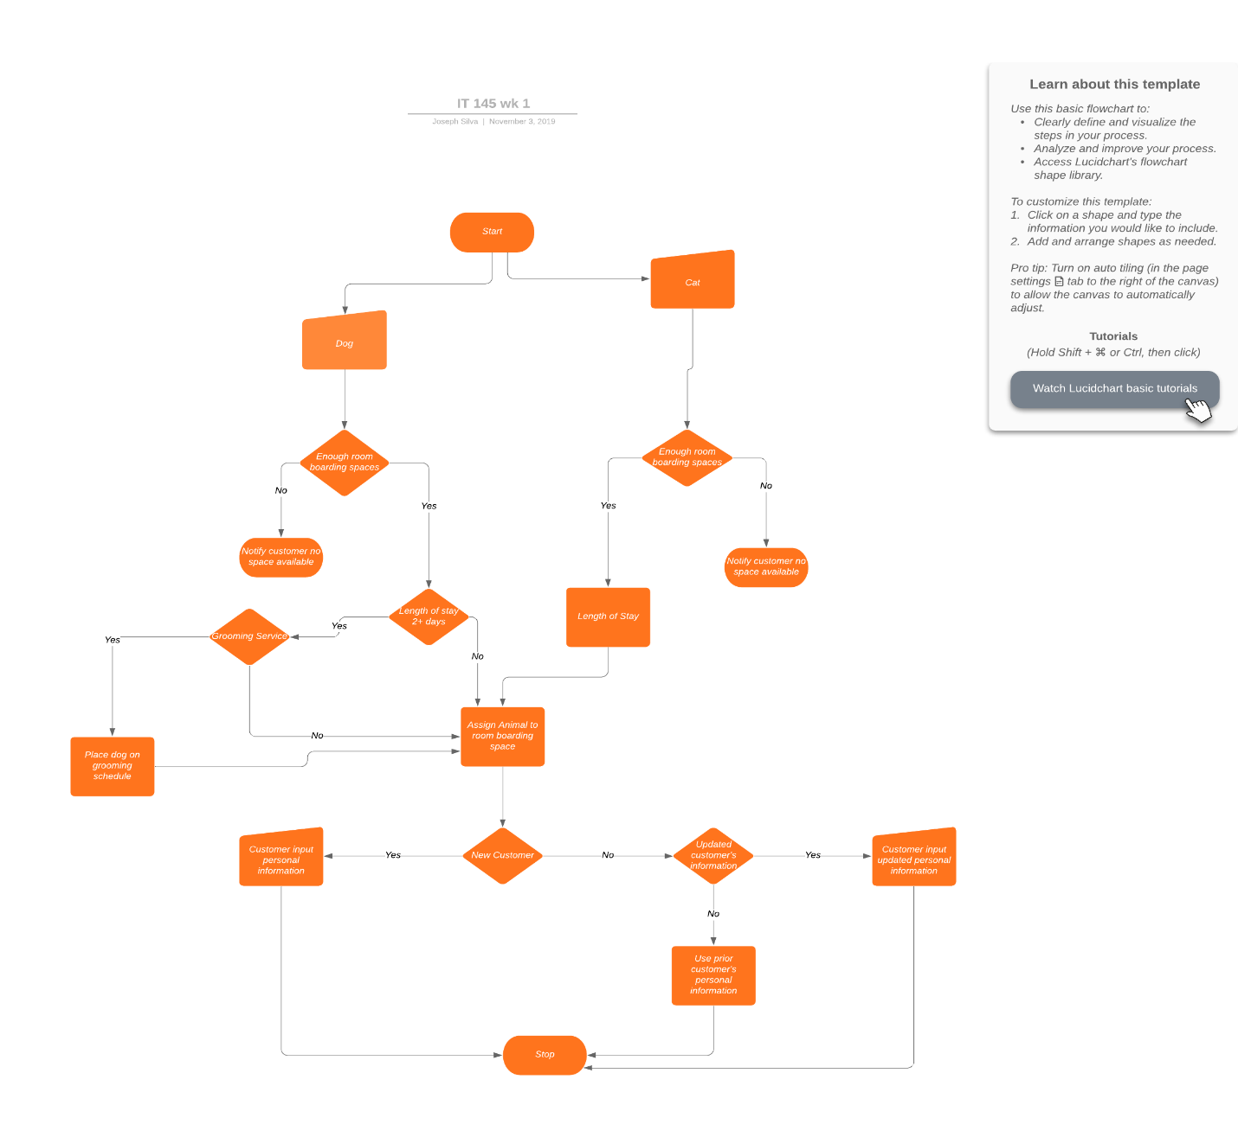

## OOP Principles Explanation

Briefly explain how you applied object-oriented programming principles in the software development process. Your explanation should be one paragraph, or four to six sentences.

|  |
| --- |
| Throughout the software development process, I gave my Dog class the ability to inherit the attributes of my Pet class by making it an extends to the Pet class. I also placed a constructor inside of my Pet class to be used in any part of my program or in the Dog class program without making a compact single program. I used polymorphism by making setters and getters for the methods inside of my Pet class. I used void to prevent not wanted outputs throughout my program. |